**LEVEL - 0**

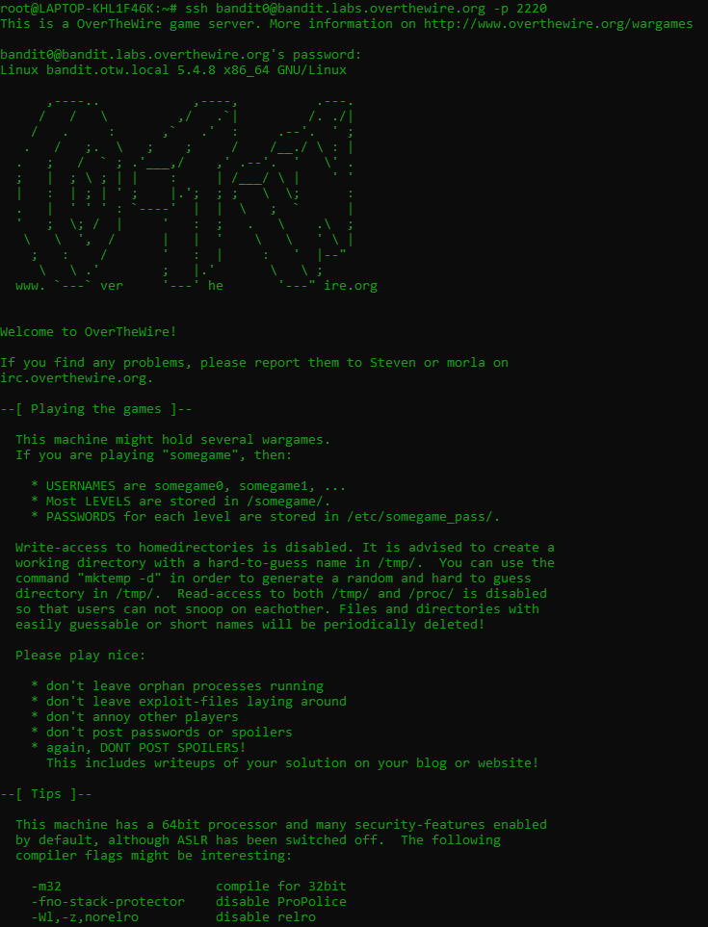

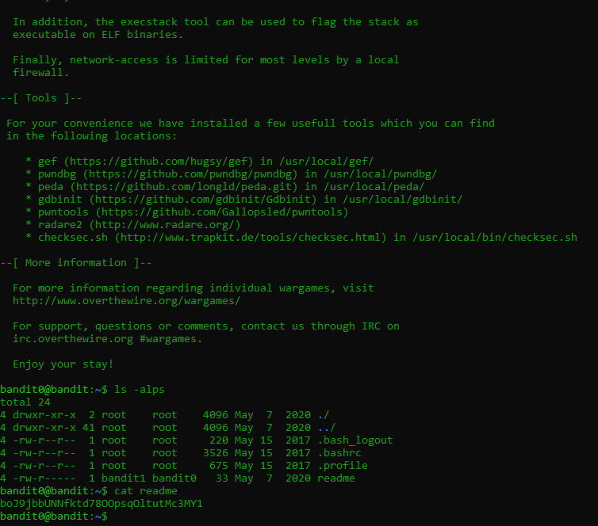

**Password - boJ9jbbUNNfktd78OOpsqOltutMc3MY1**

**LEVEL 0 to LEVEL 1**

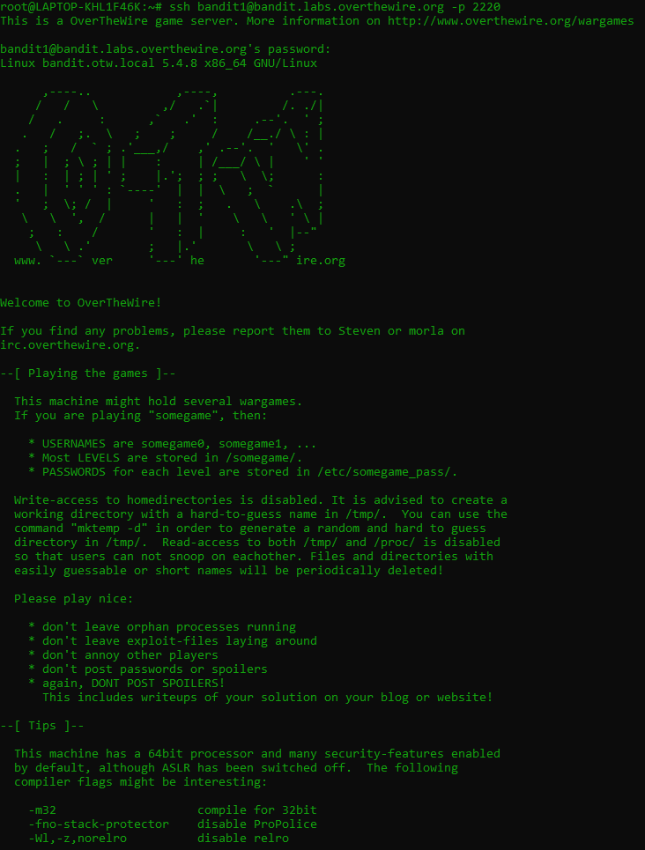

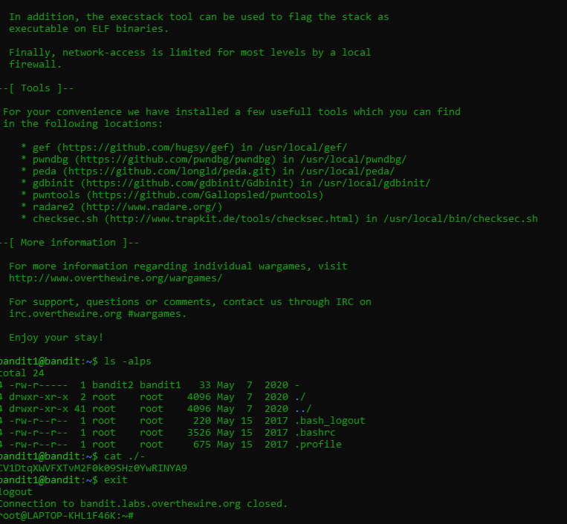

**Password - CV1DtqXWVFXTvM2F0k09SHz0YwRINYA9**

**LEVEL 1 to LEVEL 2**

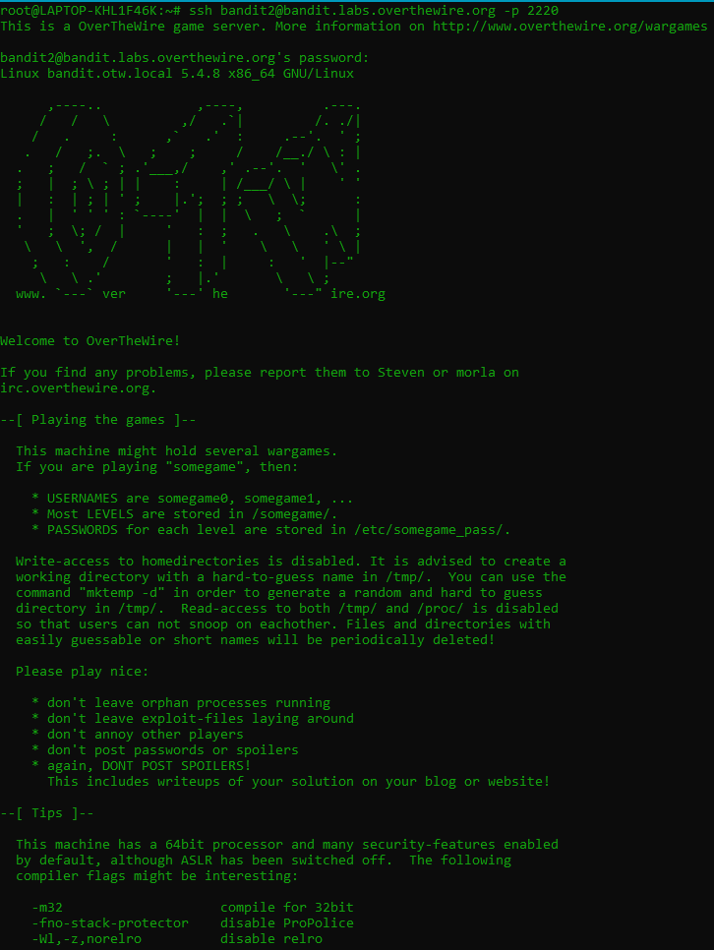

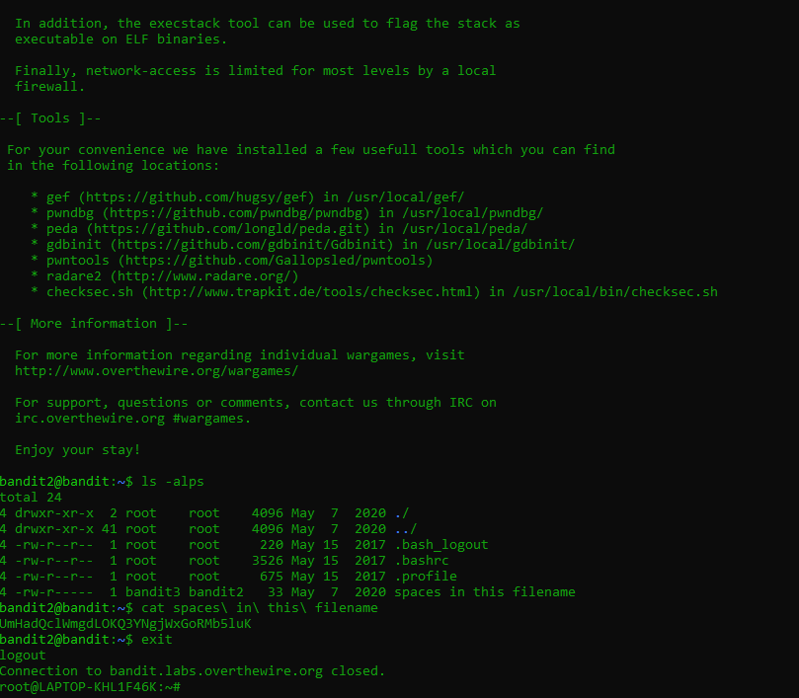

**Password - UmHadQclWmgdLOKQ3YNgjWxGoRMb5luK**

**LEVEL 2 to LEVEL 3**

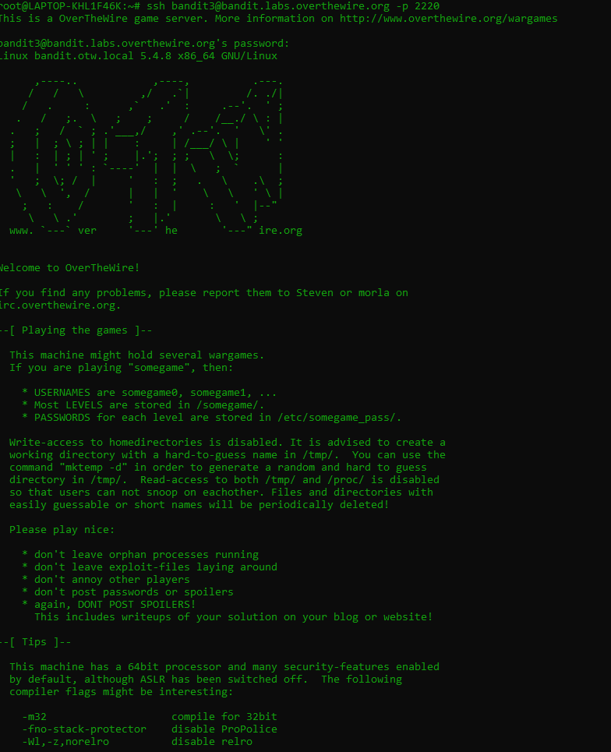

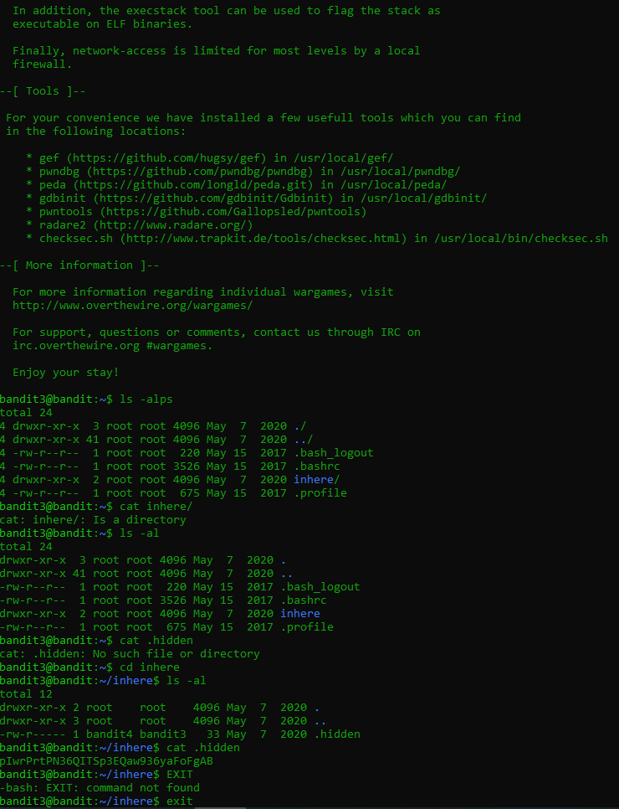

**Password - pIwrPrtPN36QITSp3EQaw936yaFoFgAB**

**LEVEL 3 to LEVEL 4**

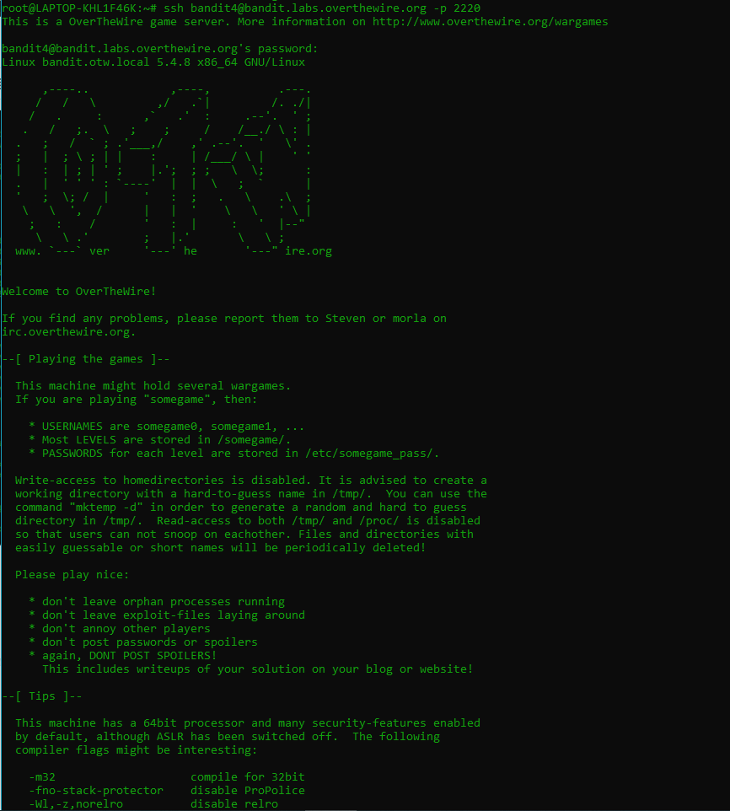

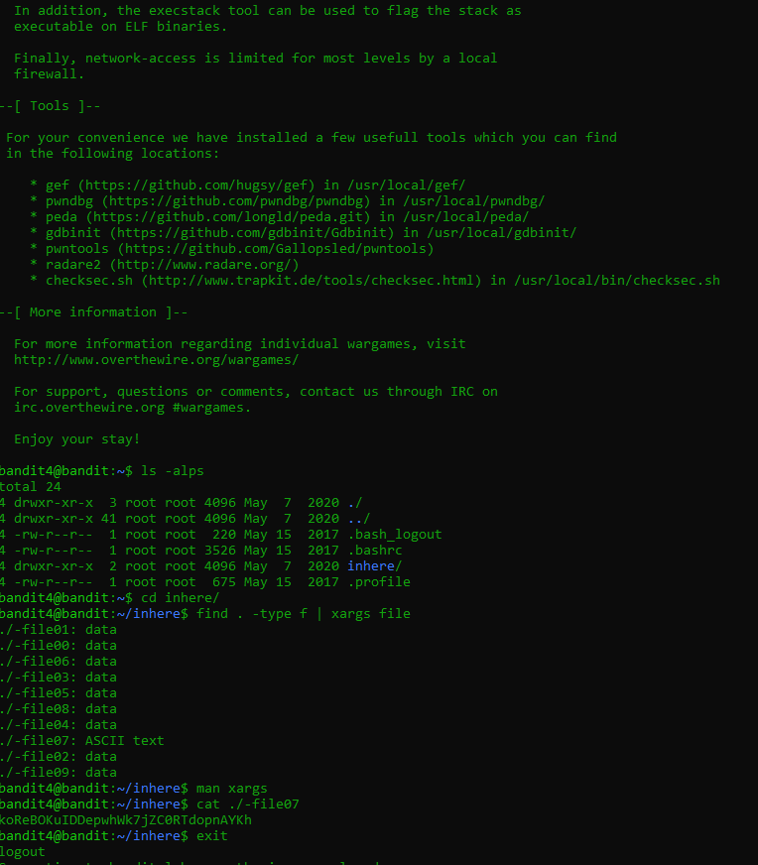

**Password - koReBOKuIDDepwhWk7jZC0RTdopnAYKh**

**LEVEL 4 to LEVEL 5**

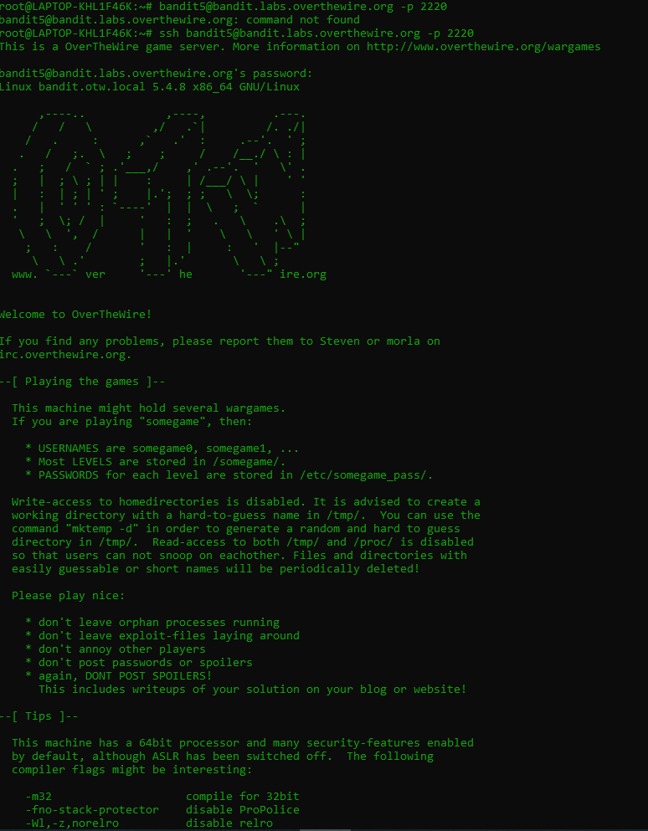

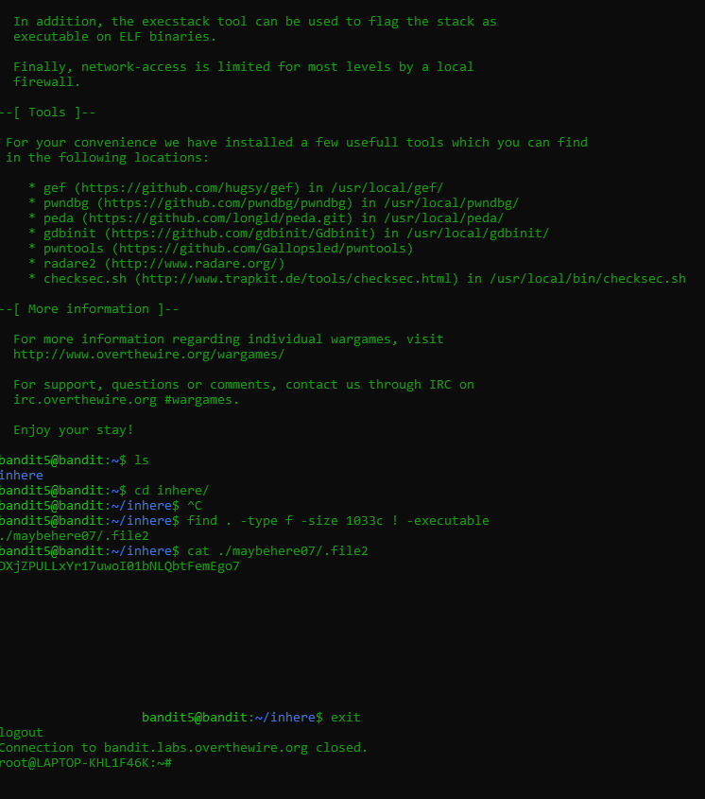

**Password - DXjZPULLxYr17uwoI01bNLQbtFemEgo7**

**LEVEL 5 to LEVEL 6**

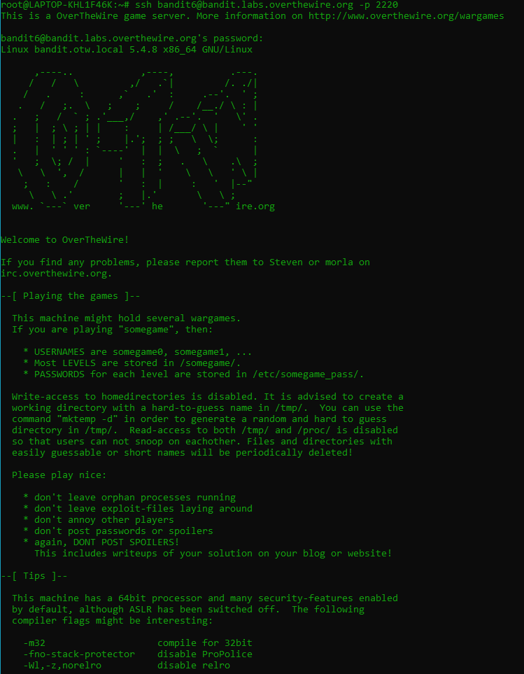

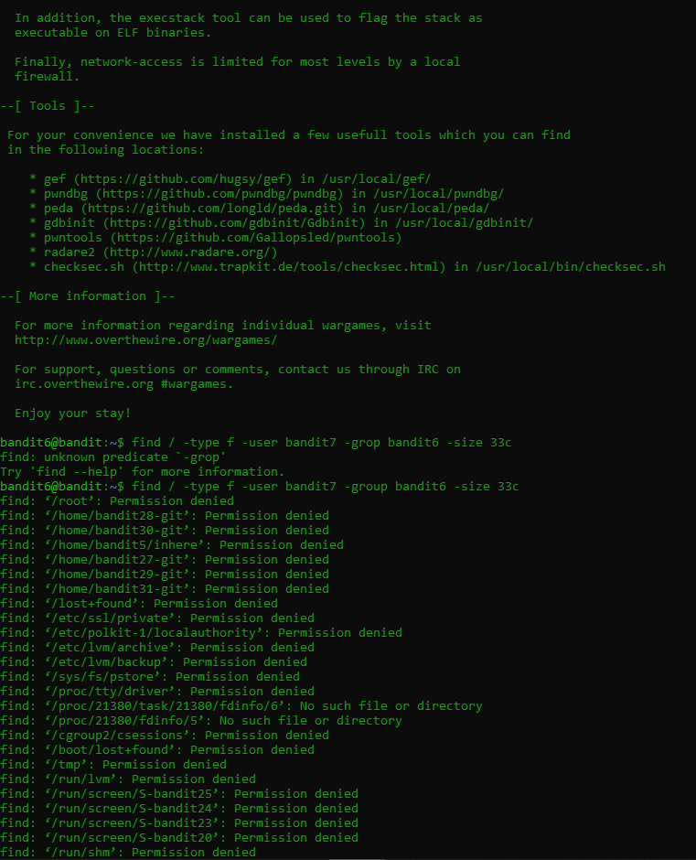

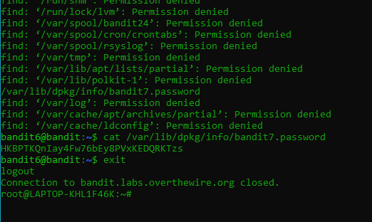

**Password - HKBPTKQnIay4Fw76bEy8PVxKEDQRKTzs**

**LEVEL 6 to LEVEL 7**

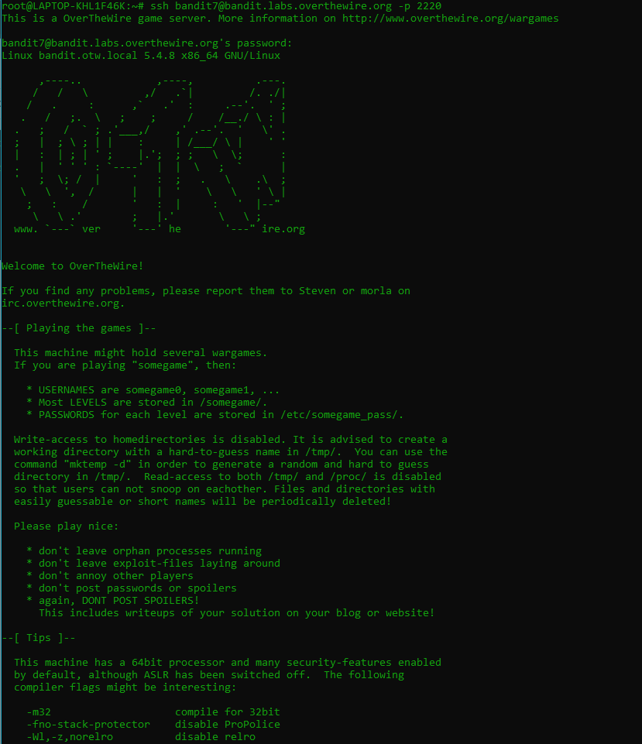

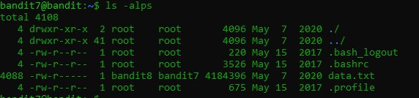



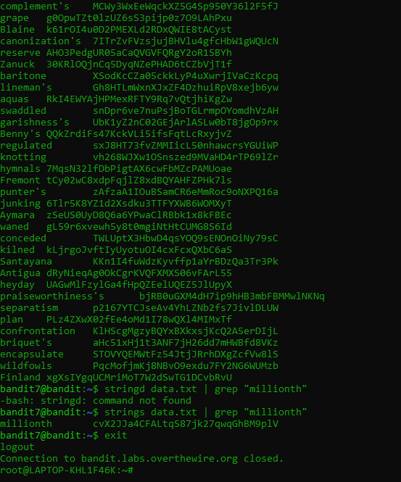

**Password - cvX2JJa4CFALtqs87jk27qwqGhBM9plV**

**LEVEL 7 to LEVEL 8**

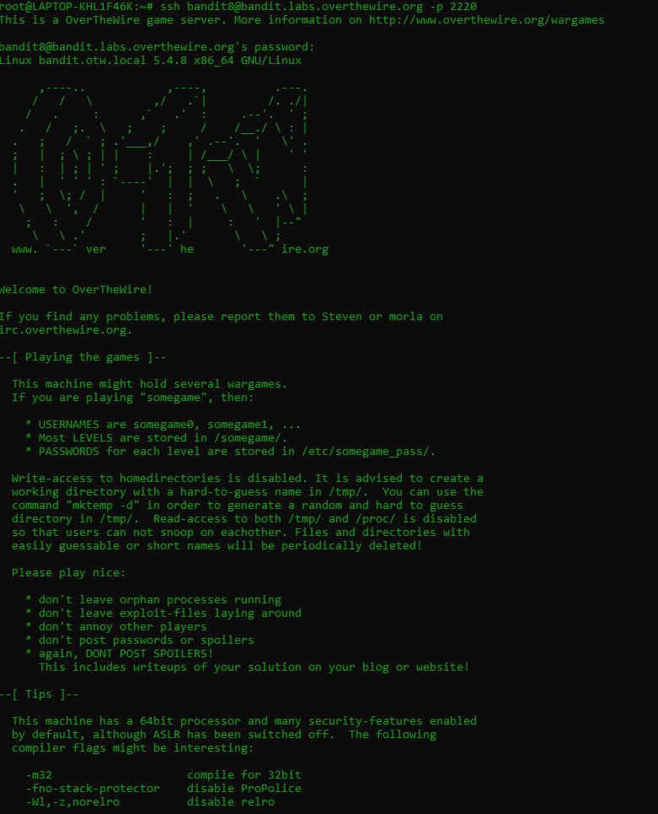

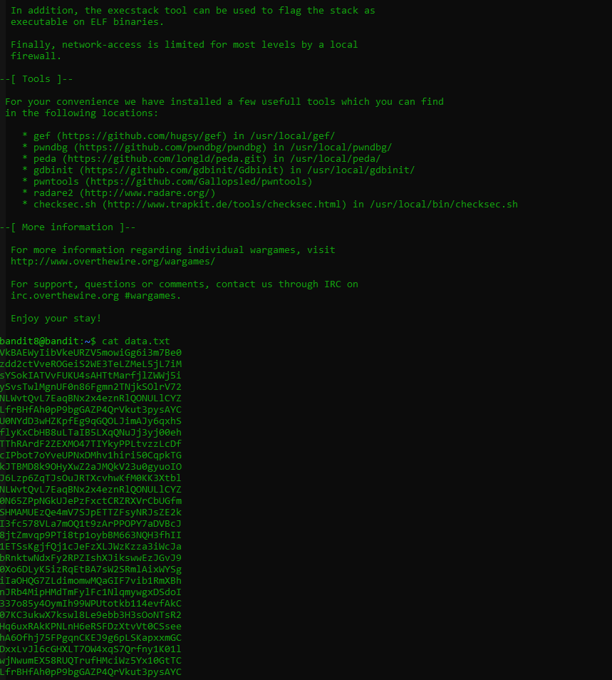

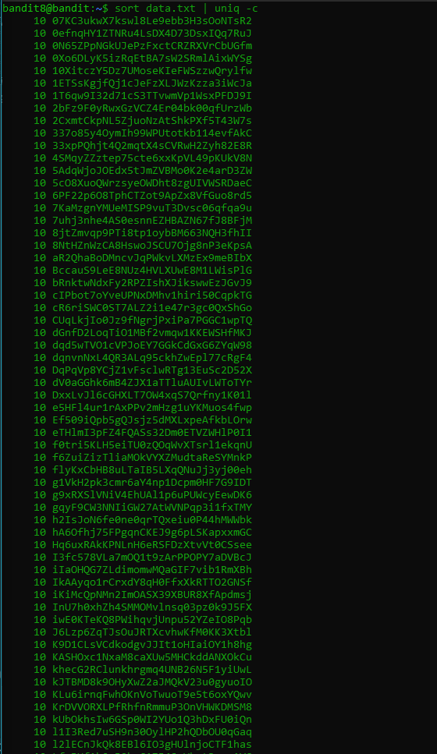.

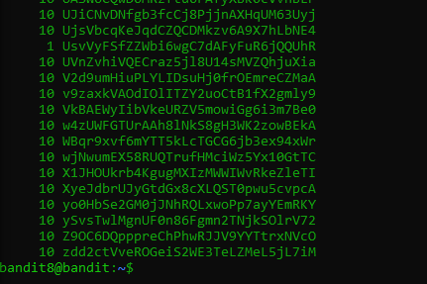

**Password - UsvVyFSfZZWbi6wgC7dAFyFuR6jQQUhR**

**LEVEL 8 to LEVEL 9**

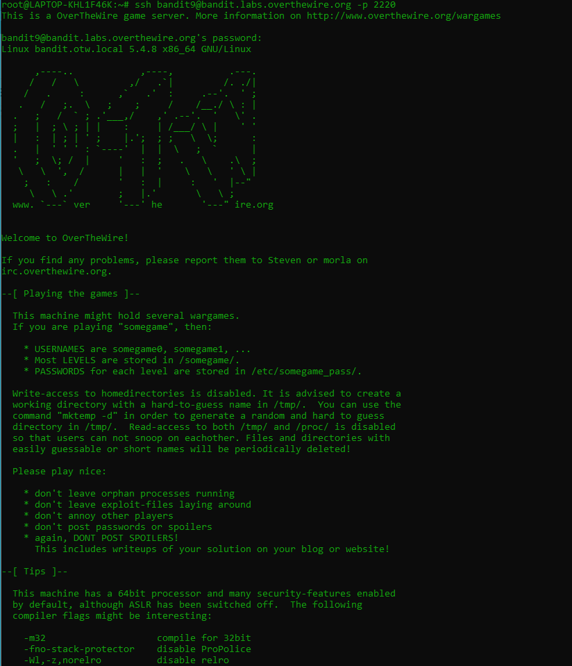

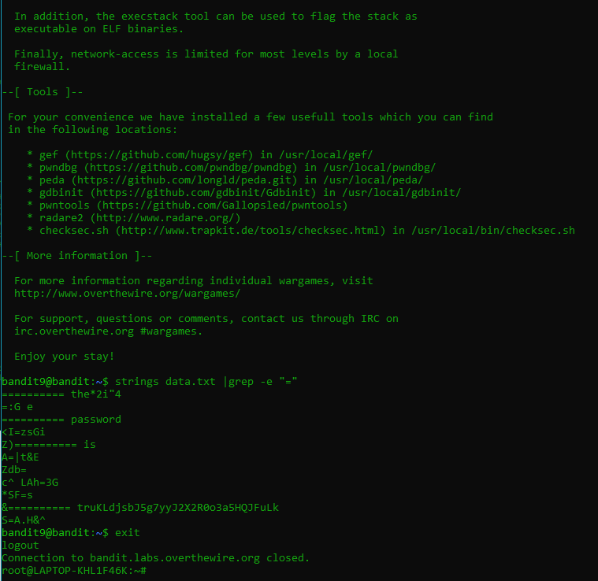

**Password - truKLdjsbJ5g7yyJ2X2R0o3a5HQJFuLk**

**LEVEL 9 to LEVEL 10**

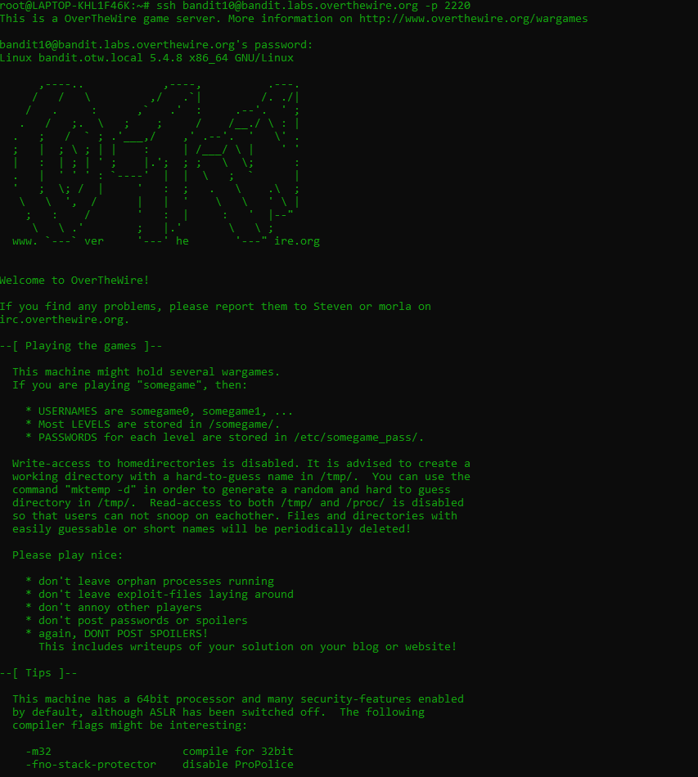

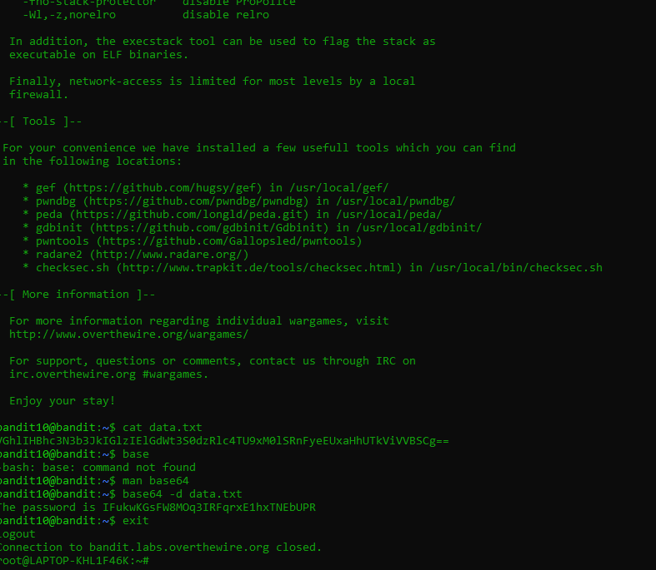

**Password - IFukwKGsFW8MOq3IRFqrxE1hxTNEbUPR**